Docker — Three-Tier Architecture:
- Deploy a three-tier application using Docker Compose: Frontend (Nginx/React) → Backend API → Database (choose MySQL or PostgreSQL).
- Configure Docker networks, persistent volumes, health checks, environment variables, restart policies, and service dependencies. Expose only the frontend externally. Demonstrate how you would troubleshoot frontend → backend and backend → database connectivity issues.

AWS EKS + ALB Controller — Three-Tier Architecture:
- Migrate the same application to Amazon EKS, continuing with your chosen MySQL or PostgreSQL database. Deploy the frontend, backend, and database using Kubernetes resources. Use ClusterIP for internal communication and expose the frontend using Ingress + AWS Load Balancer Controller (ALB). Configure Secrets/ConfigMaps, persistent storage, probes, IAM/IRSA or Pod Identity, and scaling. Demonstrate troubleshooting of Internet → ALB → Ingress → Service → Pod → Backend → Database, including ALB 503 and unhealthy-target scenarios.

AWS EKS + ALB Controller — Three-Tier Architecture:
- Migrate the same application to Amazon EKS, continuing with your chosen MySQL or PostgreSQL database. Deploy the frontend, backend, and database using Kubernetes resources. Use ClusterIP for internal communication and expose the frontend using Ingress + AWS Load Balancer Controller (ALB). Configure Secrets/ConfigMaps, persistent storage, probes, IAM/IRSA or Pod Identity, and scaling. Demonstrate troubleshooting of Internet → ALB → Ingress → Service → Pod → Backend → Database, including ALB 503 and unhealthy-target scenarios.

1# Diagram representation
INTERNET
|
(AWS ALB)
|
Kubernetes Ingress
|
frontend-service
ClusterIP
|
Frontend Pods
Nginx x 2
|
backend-service
ClusterIP
|
Backend Pods
Flask API x 2
|
database-service
ClusterIP
|
MySQL Pod
|
PersistentVolumeClaim
|
Amazon EBS
Request follow diagram
ALB = Internet-facing
Frontend Service = ClusterIP
Backend Service = ClusterIP
Database Service = ClusterIP
2# Pre requisites :-
AWS CLI
kubectl
eksctl
Helm
Docker
3# Login to aws
# aws configure --Create AWS configuration
AWS Access Key ID:
AWS Secret Access Key:
Default region name:
Default output format:
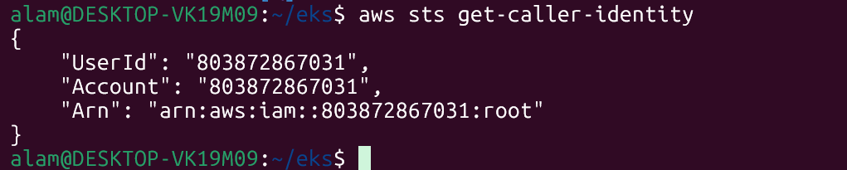
4# Create EKS Cluster
$mkdir /home/alam/eks-three-tire,
$cd /home/alam/eks-three-tire
$vim eks-cluster.yaml
apiVersion: eksctl.io/v1alpha5
kind: ClusterConfig

metadata:
name: three-tier-eks
region: ap-south-1

managedNodeGroups:

- name: worker-nodes
instanceType: t3.medium
desiredCapacity: 2
minSize: 2
maxSize: 3

volumeSize: 30
volumeType: gp3

iam:
withAddonPolicies:
ebs: true

6# Create EKS Cluster
$ eksctl create cluster -f eks-cluster.yaml ---------------------------- to create cks cluster
$ eksctl delete cluster -f eks-cluster.yaml --------------------------- to delete eks cluster
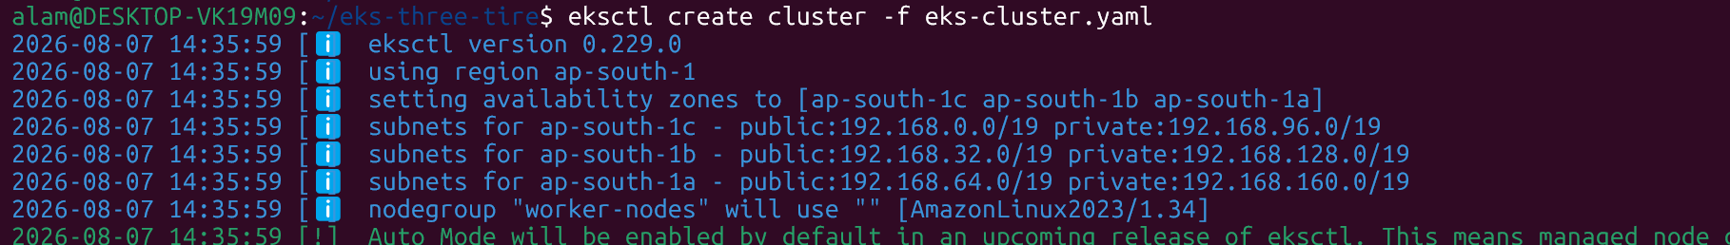
7#Verify the EKS
$kubectl get nodes

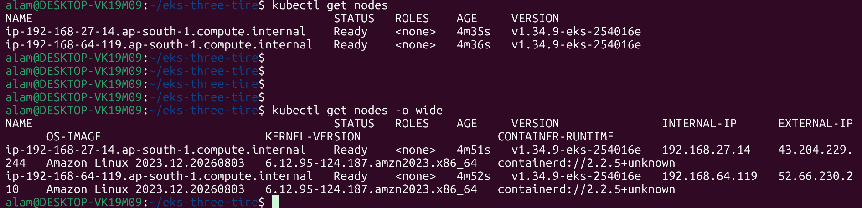
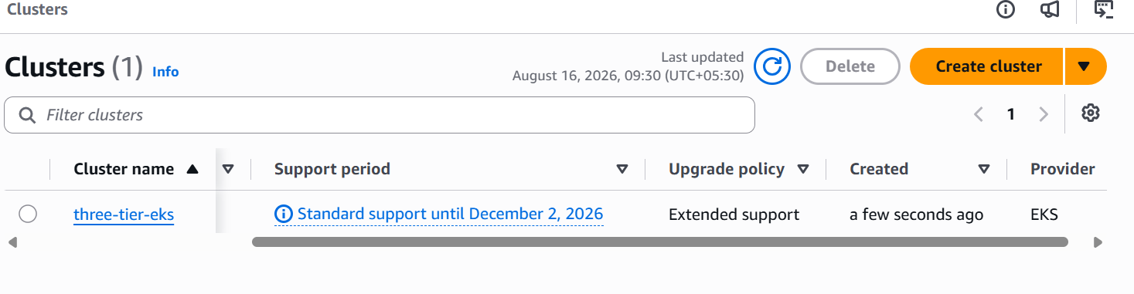
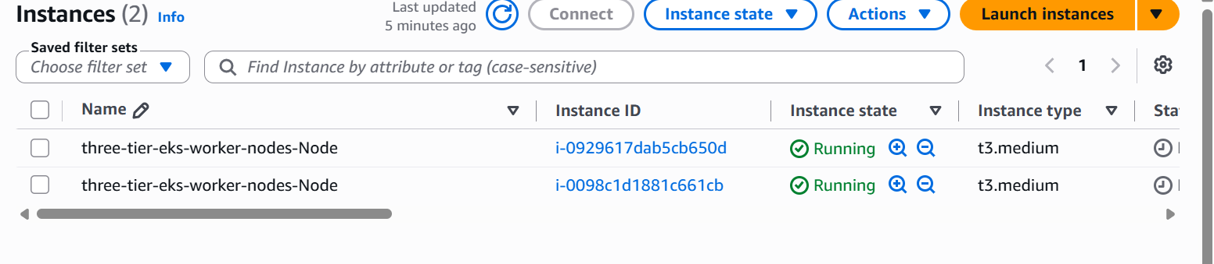
8# Install EBS CSI Driver
This is the need for the persistent volume.
Install the EBS CSI addon:
#eksctl create addon --cluster three-tier-eks --name aws-ebs-csi-driver –force
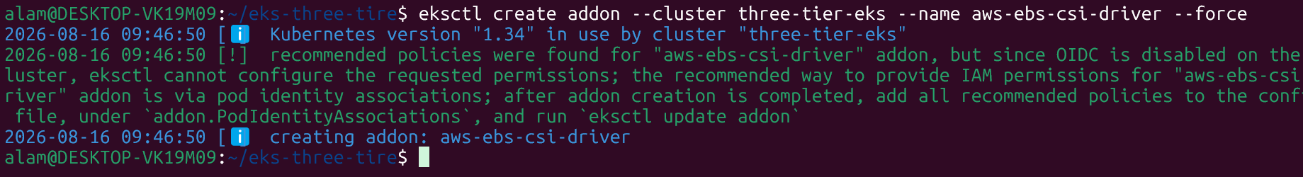
- Too se the addon
# eksctl get addon --cluster three-tier-eks
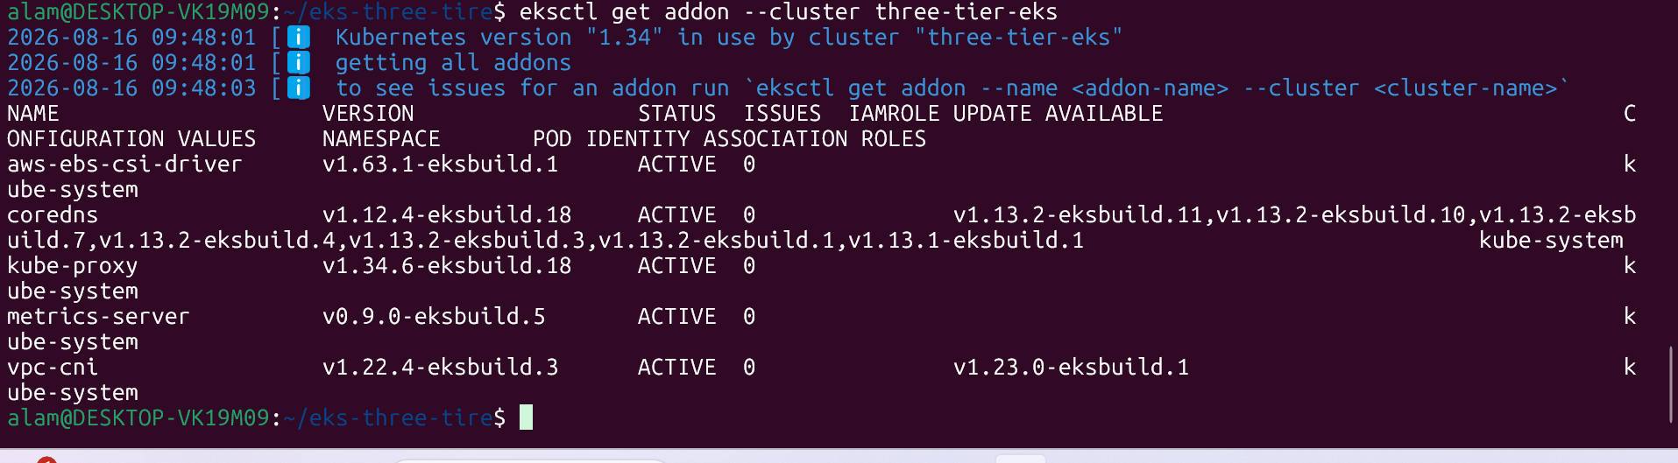

9# Create Namespace
#Vim namespace.yaml

apiVersion: v1
kind: Namespace

metadata:
name: three-tier

$ kubectl apply -f namespace.yaml
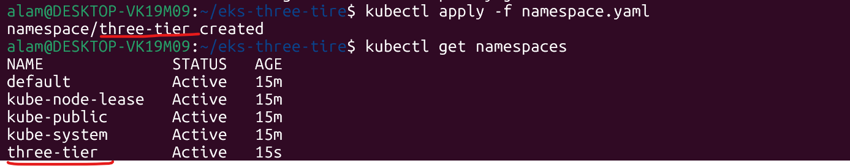

10# Create configmap
$configmap.yaml
apiVersion: v1
kind: ConfigMap

metadata:
name: backend-config
namespace: three-tier

data:
DB_HOST: database
DB_NAME: employee_db
DB_USER: admin
# kubectl apply -f configmap.yaml
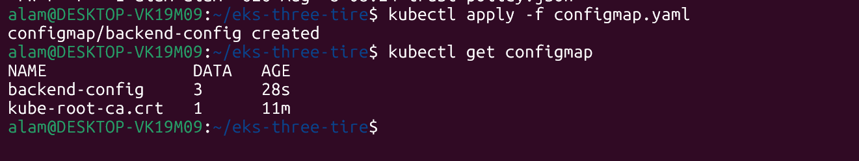

11# Create Secret
$secret.yaml
apiVersion: v1
kind: Secret
metadata:
name: database-secret
namespace: three-tier
type: Opaque
stringData:
MYSQL_ROOT_PASSWORD: root123
MYSQL_PASSWORD: admin123
$kubectl apply -f secret.yaml & check $ kubectl get secret -n three-tier
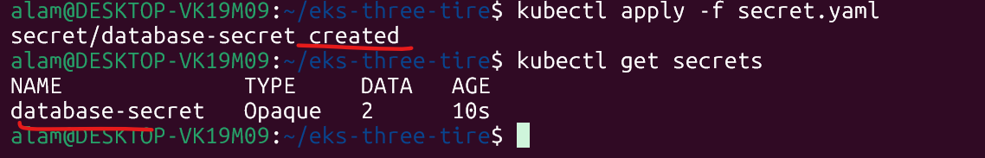
12 #MySQL Persistent Storage
$ mysql-storage.yaml
apiVersion: v1
kind: PersistentVolumeClaim
metadata:
name: mysql-pvc
namespace: three-tier
spec:
accessModes:
- ReadWriteOnce
storageClassName: ebs-sc
resources:
requests:
storage: 10Gi
$ kubectl apply -f mysql-storage.yaml ---- chek its status later
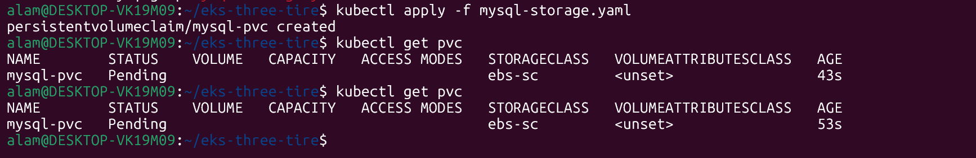

13# Create EBS StorageClass
$ storage-class.yaml
apiVersion: storage.k8s.io/v1
kind: StorageClass

metadata:
name: ebs-sc

provisioner: ebs.csi.aws.com

volumeBindingMode: WaitForFirstConsumer

parameters:
type: gp3

fsType: ext4

reclaimPolicy: Delete
# create storage class & Verify
$ kubectl apply -f storage-class.yaml
$ kubectl get storageclass
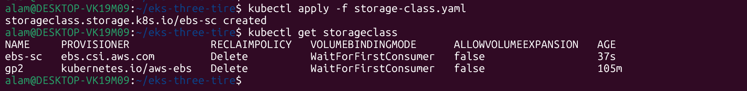
14#Apply MySQL
$ kubectl apply -f mysql-storage.yaml
$ kubectl get pvc -n three-tier ---to check
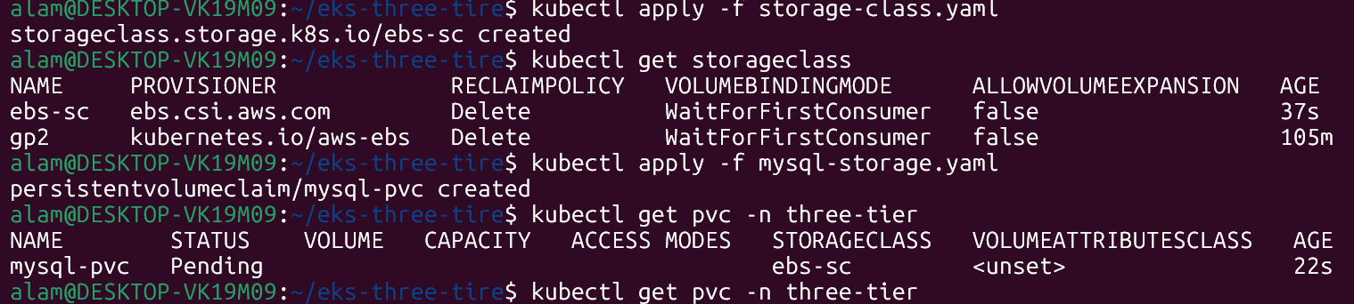
It will provision once the MYSQL pod is schedule.
15 # Mysql Deploymnet
$ mysql-deployment.yaml
apiVersion: apps/v1
kind: Deployment

metadata:
name: database
namespace: three-tier

spec:

replicas: 1

selector:
matchLabels:
app: database

template:

metadata:
labels:
app: database

spec:

containers:

- name: mysql

image: mysql:8.0

ports:
- containerPort: 3306

env:

- name: MYSQL_ROOT_PASSWORD
valueFrom:
secretKeyRef:
name: database-secret
key: MYSQL_ROOT_PASSWORD

- name: MYSQL_DATABASE
valueFrom:
configMapKeyRef:
name: backend-config
key: DB_NAME

- name: MYSQL_USER
valueFrom:
configMapKeyRef:
name: backend-config
key: DB_USER

- name: MYSQL_PASSWORD
valueFrom:
secretKeyRef:
name: database-secret
key: MYSQL_PASSWORD

volumeMounts:

- name: mysql-storage
mountPath: /var/lib/mysql

readinessProbe:

exec:
command:
- sh
- -c
- mysqladmin ping -h localhost -proot123

initialDelaySeconds: 20
periodSeconds: 10

livenessProbe:

exec:
command:
- sh
- -c
- mysqladmin ping -h localhost -proot123

initialDelaySeconds: 30
periodSeconds: 20

volumes:

- name: mysql-storage

persistentVolumeClaim:
claimName: mysql-pvc
#kubectl apply -f mysql-deployment.yaml
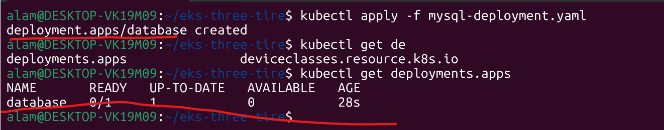

16 # Myql service
$ mysql-service.yaml
apiVersion: v1
kind: Service

metadata:
name: database
namespace: three-tier

spec:

type: ClusterIP

selector:
app: database

ports:

- port: 3306
targetPort: 3306
17# Deploy MySQL
$kubectl apply -f mysql-deployment.yaml
$ kubectl apply -f mysql-service.yaml
$ kubectl get pods -n three-tier --chek
$ kubectl get svc -n three-tier

18 # Mysq storage
$ kubectl get pvc -n three-tier
Mysql-pvc
$kubectl get pvc
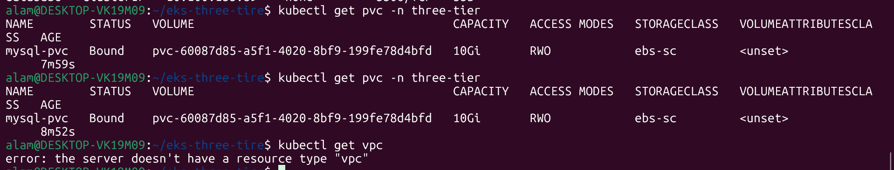
19 #backend image creation
# docker build -t qamre/three-tier-docker-compose-backend:v1 ./backend
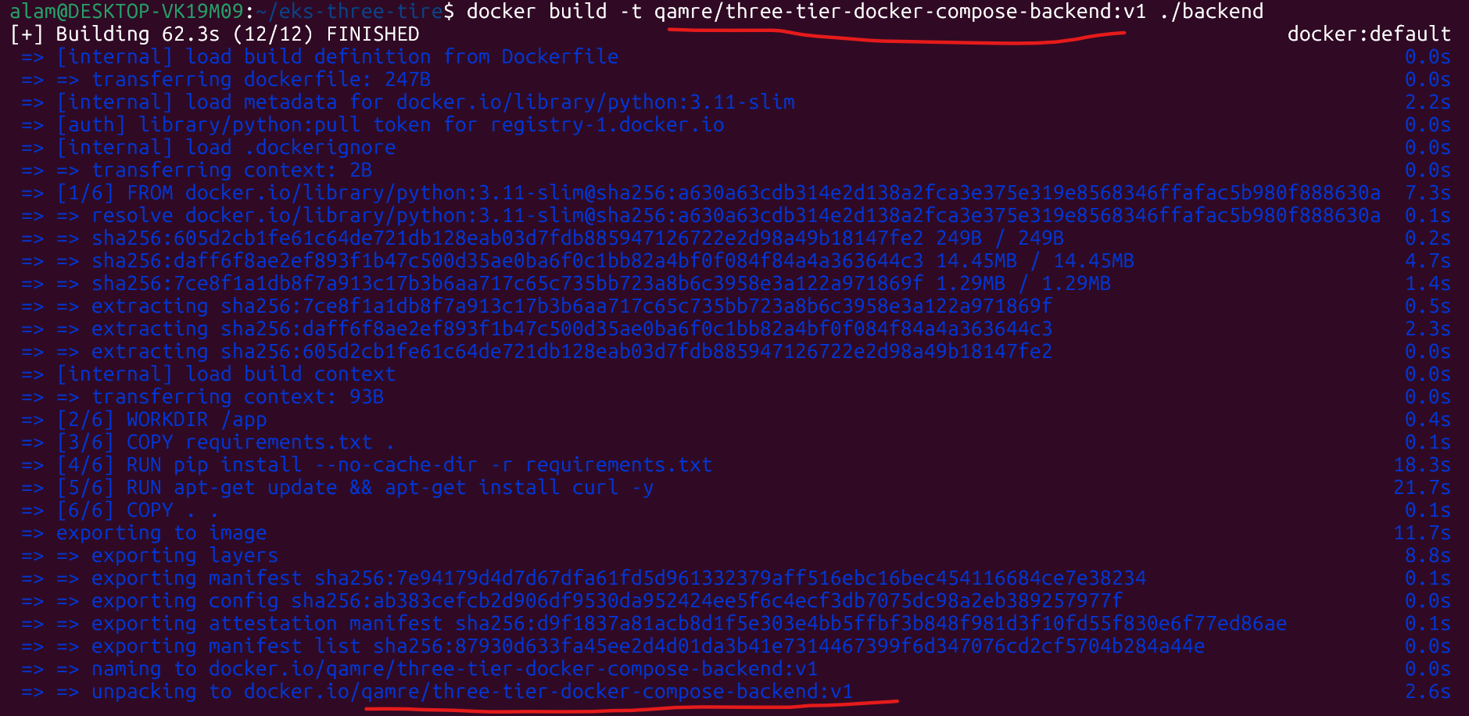
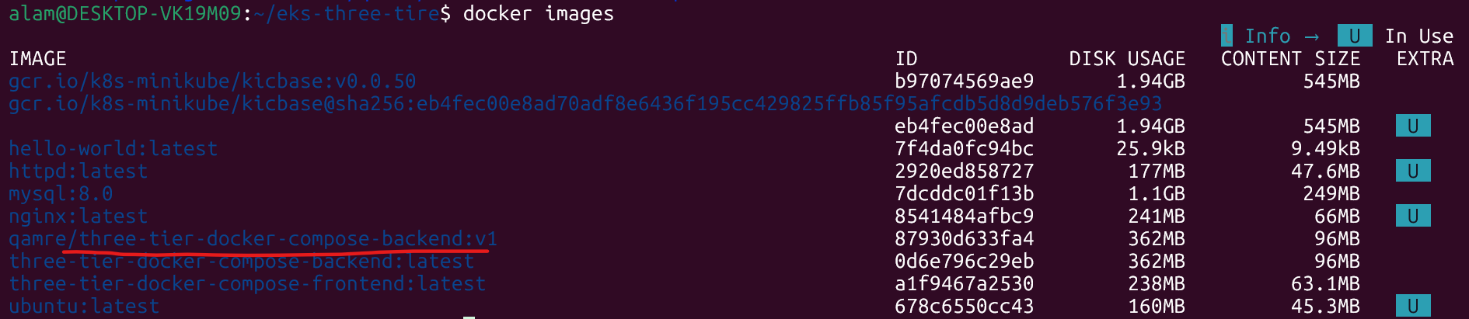
Image : - qamre/three-tier-docker-compose-backend:v1
20# front image creation
$docker build -t qamre/three-tier-docker-compose-frontend:v1 ./frontend/
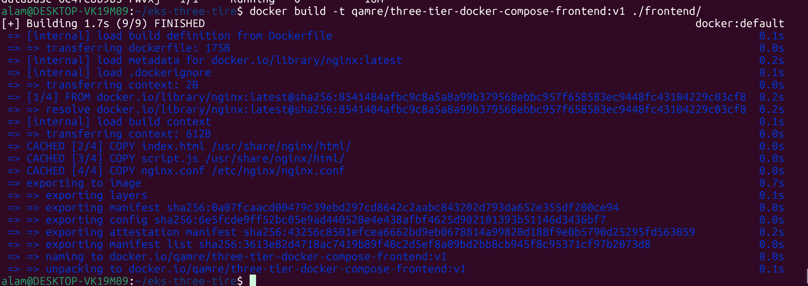
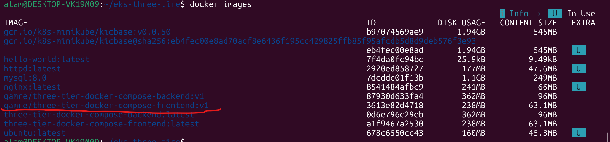
Image : - qamre/three-tier-docker-compose-frontend:v1
21# Backend Deployment
$vim backend-deployment.yaml
apiVersion: apps/v1
kind: Deployment
metadata:
name: backend
namespace: three-tier
spec:
replicas: 2
selector:
matchLabels:
app: backend
template:
metadata:
labels:
app: backend
spec:
containers:
- name: backend
image: qamre/three-tier-docker-compose-backend:v1
ports:
- containerPort: 5000
env:
- name: DB_HOST
valueFrom:
configMapKeyRef:
name: backend-config
key: DB_HOST
- name: DB_NAME
valueFrom:
configMapKeyRef:
name: backend-config
key: DB_NAME
- name: DB_USER
valueFrom:
configMapKeyRef:
name: backend-config
key: DB_USER
- name: DB_PASSWORD
valueFrom:
secretKeyRef:
name: database-secret
key: MYSQL_PASSWORD
readinessProbe:
httpGet:
path: /
port: 5000

initialDelaySeconds: 10
periodSeconds: 10
livenessProbe:
httpGet:
path: /
port: 5000
initialDelaySeconds: 20
periodSeconds: 20
22# Backend Service
$ vim backend-service.yaml
apiVersion: v1
kind: Service

metadata:
name: backend
namespace: three-tier

spec:

type: ClusterIP

selector:
app: backend

ports:

- port: 5000
targetPort: 5000
23# Deploy Backend
$ kubectl apply -f backend-deployment.yaml
$ kubectl apply -f backend-service.yaml
$ kubectl get pods -n three-tier ----to check above services
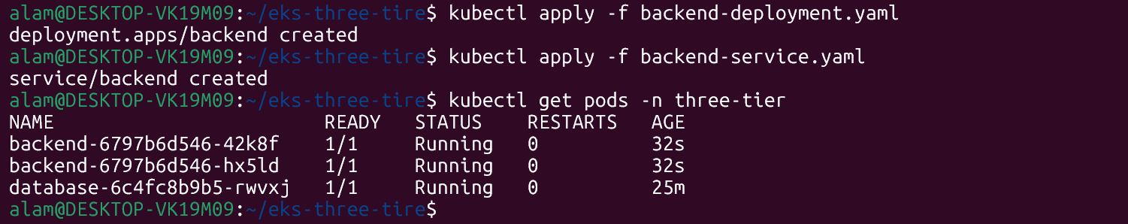
24# Test Backend
$kubectl get pods -n three-tier ---- First get the backend pod
$ kubectl exec -it <backend-pod-name> -n three-tier – sh --- login to backend server with exec
# curl http://backend:5000/ --- run inside backend server or
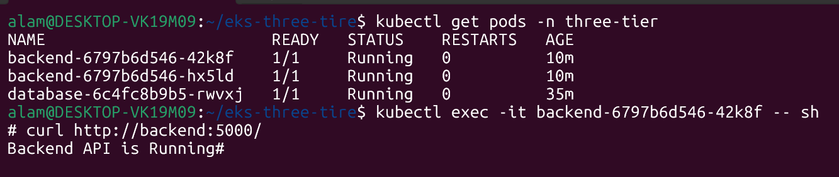
25# testing Backend → DB
$ kubectl exec -it backend-6797b6d546-79ln9 -n three-tier -- python ----------- From backend pod then run below command once logedin to the backend pod as above.
Note :- Bellow command need to dun int same below given format
$ import mysql.connector

db = mysql.connector.connect(
host="database",
user="admin",
password="admin123",
database="employee_db"
)

print("Database connected")
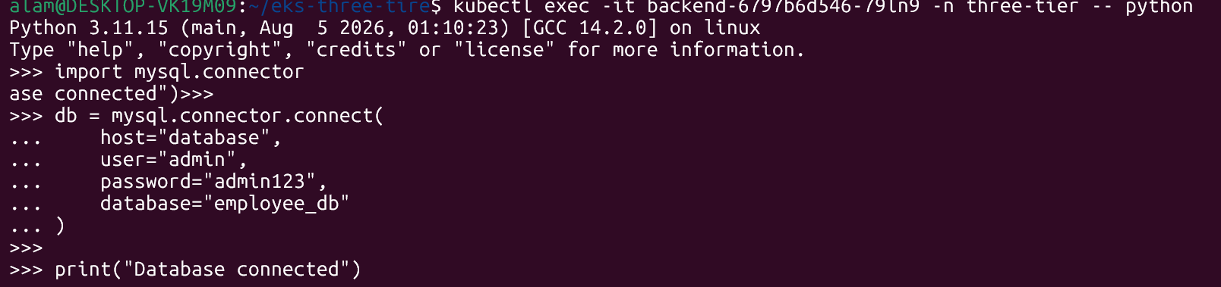
26# Frontend App Deployment
$vim frontend-deployment.yaml
apiVersion: apps/v1
kind: Deployment

metadata:
name: frontend
namespace: three-tier

spec:

replicas: 2

selector:
matchLabels:
app: frontend

template:

metadata:
labels:
app: frontend

spec:

containers:

- name: frontend

image: <dockerhub-username>/three-tier-frontend:v1

ports:
- containerPort: 80

readinessProbe:

httpGet:
path: /
port: 80

initialDelaySeconds: 5
periodSeconds: 10

livenessProbe:

httpGet:
path: /
port: 80

initialDelaySeconds: 15
periodSeconds: 20
27# Frontend Service creation
$ frontend-service.yaml
apiVersion: v1
kind: Service

metadata:
name: frontend
namespace: three-tier

spec:

type: ClusterIP

selector:
app: frontend

ports:

- port: 80$
targetPort: 80
28# Deploy Frontend
$ kubectl apply -f frontend-deployment.yaml
$ kubectl apply -f frontend-service.yaml
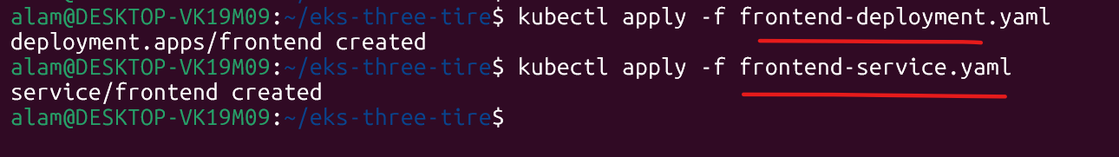
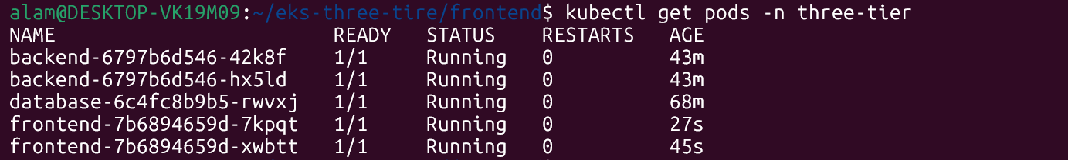
$ kubectl get pods -n three-tier ---- to chek
$ kubectl get svc -n three-tier ---- to check -----done
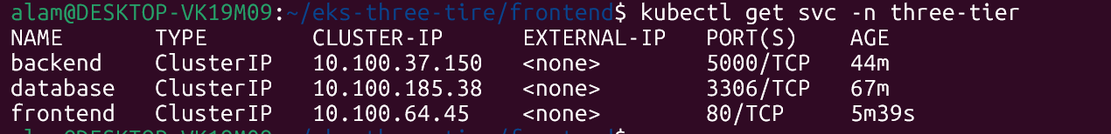
Note: - All pods should be running
29# Install AWS Load Balancer Controller on server
The controller watches Kubernetes Ingress resources and creates/manages AWS load balancers.
AWS's current Helm installation uses an IAM service account and Helm chart.
First associate OIDC:
$ eksctl utils associate-iam-oidc-provider --cluster three-tier-eks --approve ----Done
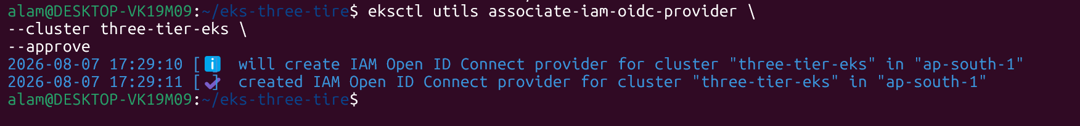
30# Download IAM Policy from AWS
$ curl -O https://raw.githubusercontent.com/kubernetes-sigs/aws-load-balancer-controller/v2.14.1/docs/install/iam_policy.json
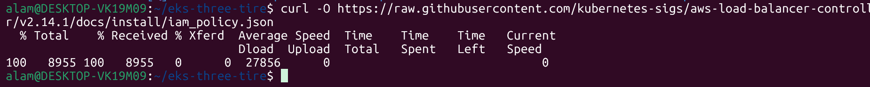 Done successfully
#Creat and apply AMI policies. -----Appy AMI policies
$ aws iam create-policy \
--policy-name AWSLoadBalancerControllerIAMPolicy \
--policy-document file://iam_policy.json
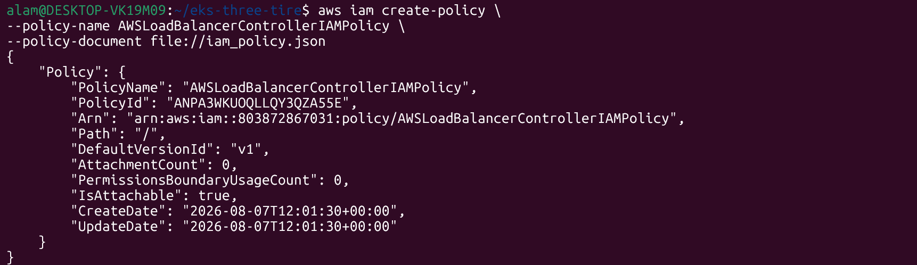
# fetch your AWS account ID:
$aws sts get-caller-identity \ --query Account \ --output text --------------------------------- Done
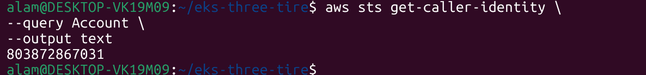
31# Create IAM Service type Account
eksctl create iamserviceaccount \
--cluster three-tier-eks \
--namespace kube-system \
--name aws-load-balancer-controller \
--attach-policy-arn arn:aws:iam:: :803872867031:policy/AWSLoadBalancerControllerIAMPolicy \
--override-existing-serviceaccounts \
--region ap-south-1 \
--approve
Note :- Make sure to change the above :803872867031 --- id from below command
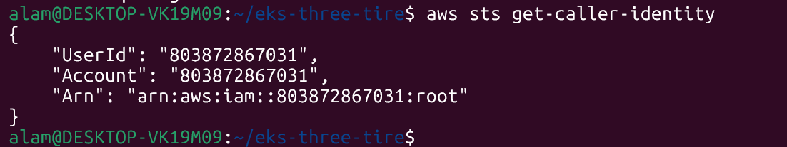
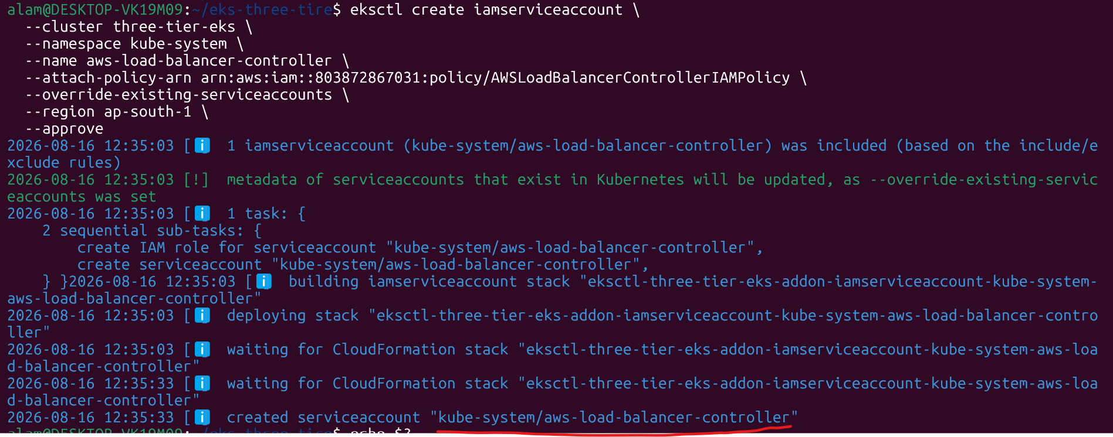

This gives the controller AWS permissions without putting AWS credentials inside the container. AWS documents this IAM/service-account approach for the controller
32# Helm Chart installation
$ helm repo add eks https://aws.github.io/eks-charts
$ helm repo update eks --- update repo
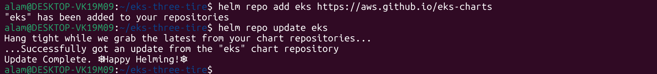
Install helm
helm install aws-load-balancer-controller \
eks/aws-load-balancer-controller \
-n kube-system \
--set clusterName=three-tier-eks \
--set serviceAccount.create=false \
--set serviceAccount.name=aws-load-balancer-controller \
--version 1.14.0
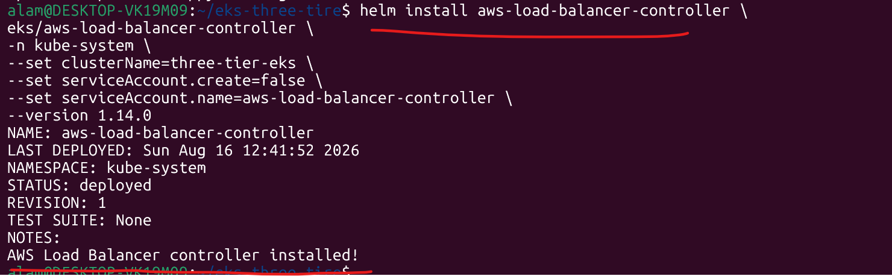
#Check and verify
$ kubectl get deployment \ aws-load-balancer-controller \ -n kube-system
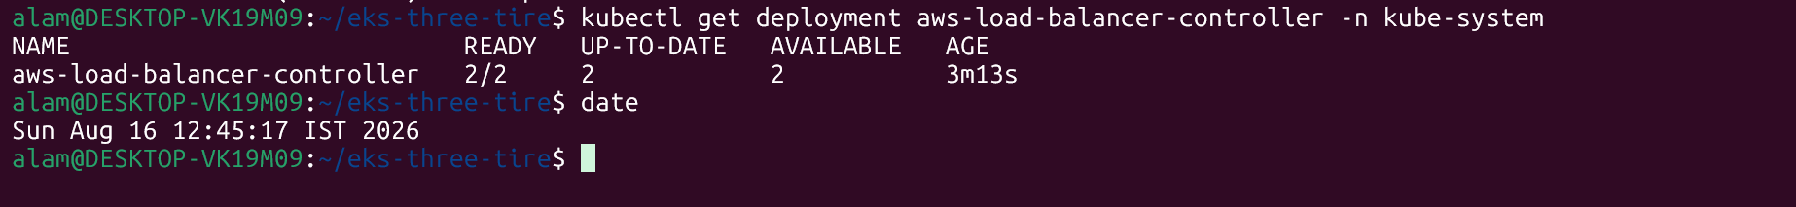
33# Create Ingress policies
$ ingress.yaml
apiVersion: networking.k8s.io/v1
kind: Ingress
metadata:
name: three-tier-ingress
namespace: three-tier
annotations:
alb.ingress.kubernetes.io/scheme: internet-facing
alb.ingress.kubernetes.io/target-type: ip
alb.ingress.kubernetes.io/listen-ports: '[{"HTTP":80}]'
alb.ingress.kubernetes.io/healthcheck-path: /
alb.ingress.kubernetes.io/healthcheck-port: traffic-port
alb.ingress.kubernetes.io/success-codes: "200"
spec:
ingressClassName: alb
rules:
- http:
paths:
- path: /
pathType: Prefix

backend:
service:
name: frontend
port:
number: 80
34# apply ingress deployment
$ kubectl apply -f ingress.yaml
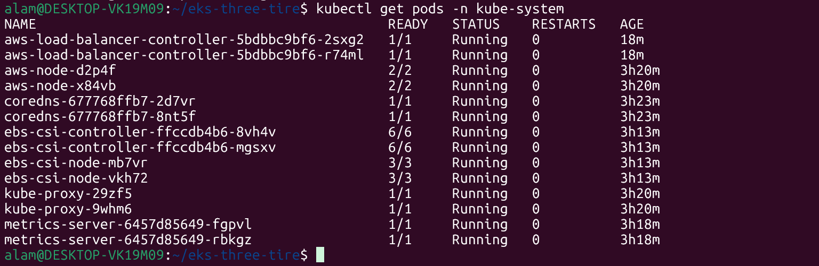
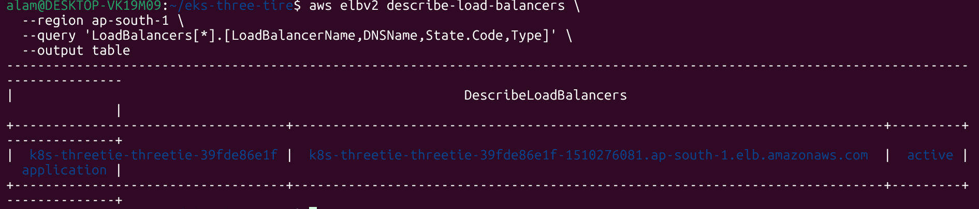

35. Application testing and confirmation
http://k8s-threetie-threetie-39fde86e1f-1510276081.ap-south-1.elb.amazonaws.com/ ---- AWS ALB DNS name.

#frontend API check
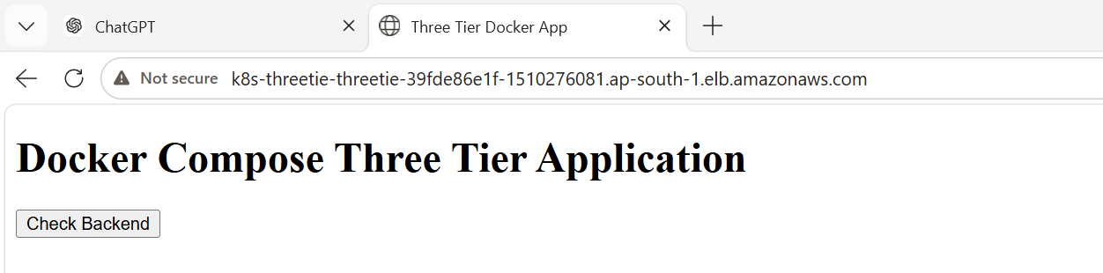

Backend API is running.
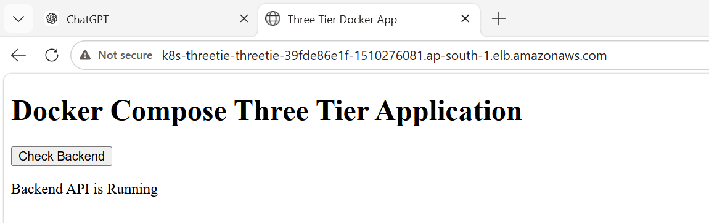
#Snapshot from the AWS consoles.
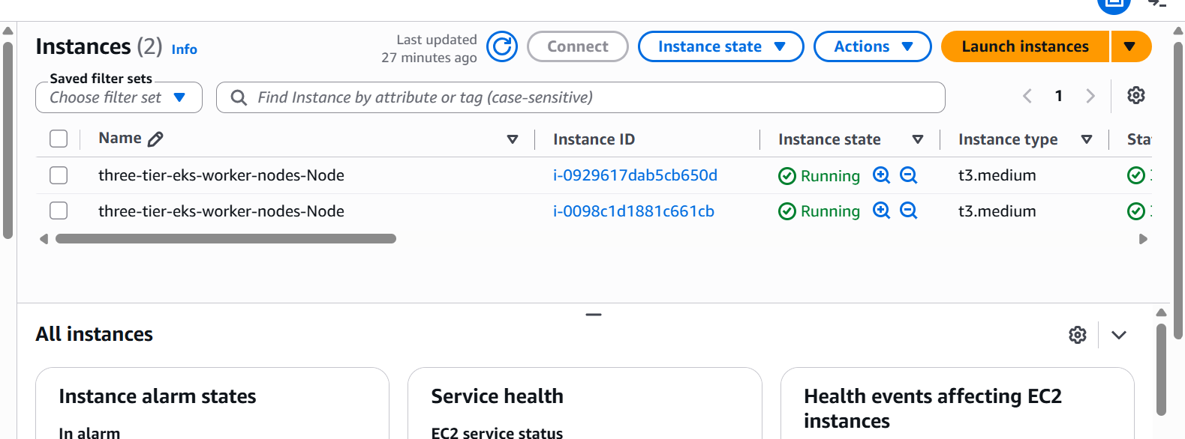
#Loadbalancer
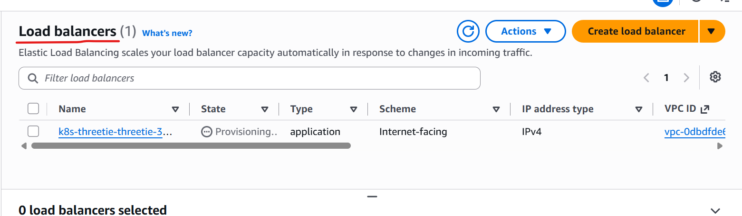

#EKS-cluster
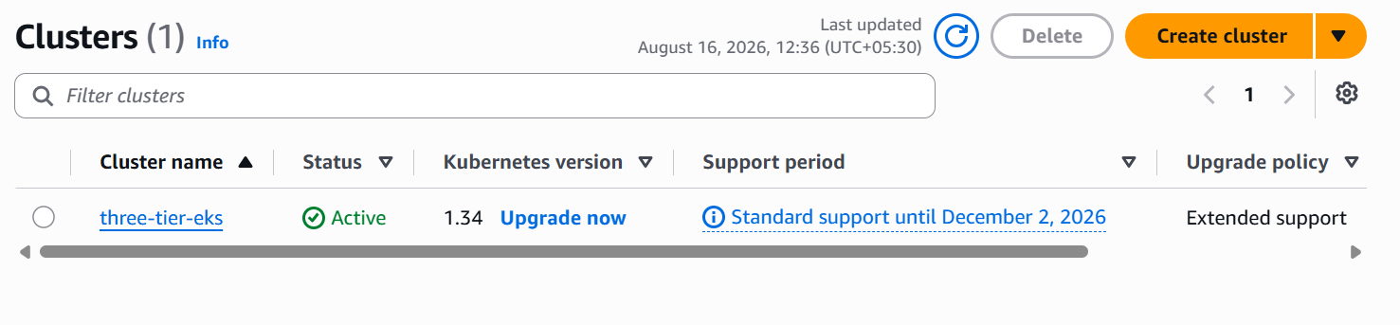
#Project flow chart
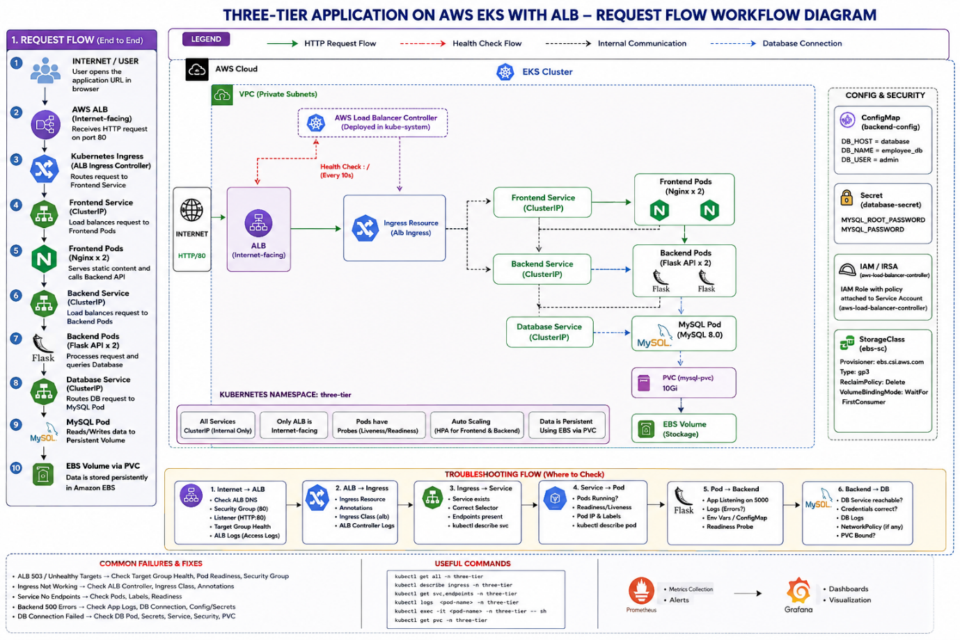

36# Project deployment order is as below
1. AWS CLI
↓
2. EKS Cluster
↓
3. EBS CSI Driver
↓
4. Namespace
↓
5. ConfigMap
↓
6. Secret
↓
7. StorageClass
↓
8. MySQL PVC
↓
9. MySQL Deployment
↓
10. MySQL Service
↓
11. Backend Deployment
↓
12. Backend Service
↓
13. Frontend Deployment
↓
14. Frontend Service
↓
15. AWS Load Balancer Controller
↓
16. Ingress
↓
17. ALB
↓
18. HPA
↓
19. Testing
↓
20. Troubleshooting
36# Learning from this task
The key takes away is I have try to demonstrate a three tire application running on AWS EKS with frontend, backend and DB as MySQL, using AWS ALB ingress network, with IAM integration, while exposing the frontend network only to internet.s

